|  |  |
| --- | --- |
| Samuel Raybone |  |

**Puvis (de Chavannes), Pierre-Cécile (1824-1898)**

Pierre Puvis de Chavannes was a French painter and draughtsman, active between 1850 and 1898. He achieved wide acclaim during his lifetime and profoundly influenced modernism. After the 1850s, Puvis produced two kinds of works which shared many formal characteristics, but differed greatly in intention and effect. The first strand consisted of large murals commissioned for various public buildings around France. In the 1860s, Puvis developed a decorative style based on a high-minded classicism, characterised by washed-out colours, flattened forms with little modelling, strongly outlined figures, rhythmically arranged compositions and a proto-modernist economy of brushstroke. Puvis was attentive to the architectural contexts of the murals: their flattened pictorial space harmonised with the two-dimensionality of the wall and their mute palette and repetitive composition matched the prevailing Beaux-Arts architectural style. The subject of these murals celebrated the values of bourgeois France: national patrimony, stability, tradition and the family. Puvis applied these decorative principles to the second strand of his work, private easel paintings. In contrast, these paintings frustrated easy interpretation; they depicted psychologically challenging, ambiguous, and unsettling scenes. It was to these highly innovative paintings that subsequent post-Impressionist and Symbolist artists would look with greatest enthusiasm.

Puvis was born in 1824 in Lyon to a wealthy bourgeois family descended from Burgundian aristocracy. Upon returning from a tour of Italy in 1846, Puvis resolved to become a painter. His training was neither regular nor sustained: he studied only briefly with Eugène Delacroix (1798-1863), Henri Scheffer (1798-1862) and Thomas Couture (1815-1879). Puvis was largely self-taught, and most influenced by the work of his friend Théodore Chassériau (1819-1856).

In the early 1850s Puvis worked without success in a Romantic mode influenced by Delacroix. After executing a decorative scheme illustrating the four seasons for his brother’s château in Le Brouchy, Saône-et-Loire, Puvis dedicated himself to decorative classicism. In the 1860s he executed murals for the Musée de Picardie in Amiens and the Musée des Beaux-Arts in Marseilles.

Puvis experienced the Franco-Prussian War and Paris Commune as personal and national traumas, expressed in his easel paintings of the 1870s, such as *L'Espérance* (1872). His public murals, including *Ludus pro Patria* (1883),became restorative and patriotic visions of an essential and untroubled France; a languid and palatable classical mode that Puvis employed until his death. The 1880s and 1890s brought Puvis multiple public commissions, wide acclaim, and an active role in the institutional art world: he was a member of Salon juries, founded and led the Société Nationale des Beaux-Arts, and received an honorary banquet in 1895.

Alongside Arcadian idylls, Puvis continued to produce disconcerting easel paintings. Their formal simplicity, vague narrative and psychological ambiguity spoke to a generation who saw isolation and alienation as quintessentially modern afflictions. *Le Pauvre* *Pêcheur* (1881) exemplifies this style, exalted by Post-Impressionists including Edgar Degas (1834-1917), Paul Gauguin (1848-1903) and Georges Seurat (1859-1891); and Symbolists including Édouard Vuillard (1868-1940), Pierre Bonnard (1867-1947) and Maurice Denis (1870-1943). Puvis died in Paris in 1898.

**The accompanying image I would suggest is Le Pauvre Pêcheur (The Poor Fisherman), 1881. It is owned by the Musée d’Orsay and its inventory number is RF 506. The copyright is held by the RMN, Musée d’Orsay. It is intended to be an example.**

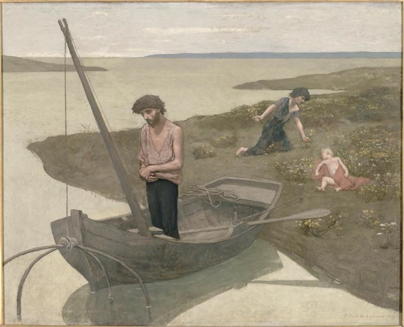

**http://www.musee-orsay.fr/en/collections/index-of-works/notice.html?no_cache=1&nnumid=001069&cHash=d53fbfc182**

**<http://www.photo.rmn.fr/c/htm/CSearchZ.aspx?o=&Total=354&FP=77346550&E=2K1KTSJV5TB0D&SID=2K1KTSJV5TB0D&New=T&Pic=5&SubE=2C6NU0VASW2E>**

**References and Further Reading**

Mitchell, Claudine (1989) ‘Time and the Idea of Patriarchy in the Pastorals of Puvis de Chavannes’, *Art History* 10 (2): 188-202.

Petrie, Brian and Simon Lee (ed.) (1997) *Puvis de Chavannes*, Aldershot: Ashgate Publishing.

Price, Aimée Brown (2010) *Pierre Puvis de Chavannes* (2 vols.), New Haven and London: Yale University Press.

Price, Aimée Brown (ed.) (1994) *Pierre Puvis de Chavannes*, ex. cat., New York: Rizzoli.

Robinson, William H. (1991) ‘Puvis de Chavannes’s “Summer” and the Symbolist Avant-Garde’, *The Bulletin of the Cleveland Museum of Art* 78 (1): 2-27.

Shaw, Jennifer L. (2002) *Dream States. Puvis de Chavannes, Modernism, and the Fantasy of France*, New Haven and London: Yale University Press.

Vachon, Marius (1895, new ed. 1900) *Puvis de Chavannes,* Paris: Société d'édition artistique.

Werth, Margaret (2002) *The Joy of Life. The Idyllic in French Art, circa 1900*, Berkeley, Los Angeles and London: University of California Press.